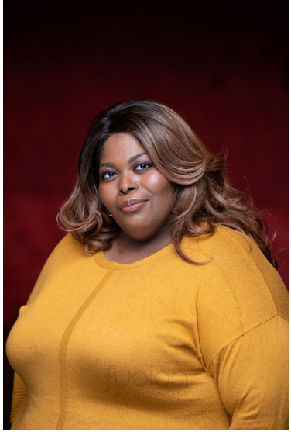
Eyes: Brown
Hair: Black
Voice: Mezzo Soprano

Paula O.L o c kh art

DIRECTOR CREDITS

August: Osage County (Jan 2023) Commonwealth Theatre Center Louisville, KY

Fairview Commonwealth Theatre Center Louisville, KY

Before It Hits Home Commonwealth Theatre Center Louisville, KY

PERFORMANCE CREDITS
A Streetcar Named Desire Eunice Hallie Dizdarevic Commonwealth Theatre Center Bowling for Beginners Pearl Mitchell Martin Commonwealth Theatre Center

Fences
This is Not the Play
Rose
Playwright
Baron Kelly
Jake Beamer
University of Louisville
The Bard’s Town

Bloodline Rumba (world premiere) Abuela Nefertiti Burton University of Louisville

Polaroid Stories Hurt Village
ACP: Richard the Third Trust
Freedom Days
All The Pretty Princesses
Persphone/Semele Big Mama
Sara Becca Sondra Aurora
Laura Early Candice Handy Baron Kelly Daniel Hill
Russell Vandenbroucke Rose Kennedy
University of Louisville University of Louisville University of Louisville University of Louisville University of Louisville Wesleyan College

Flyin’ West (KCACTF Nomination) Miss Leah
Frazer Lively
Wesleyan College

THEATRE FOR YOUNG AUDIENCES
Molly Whuppie Molly Whuppie Jennifer Pennington Commonwealth Theatre Center Fables: Anything but Aesop Lena Mera Corlett Commonwealth Theatre Center Red Riding Hood Officer O’Malley Mera Corlett Commonwealth Theatre Center Trickster Tales Sky God/Yanribo/Wild Cow Andrew Harris UofL Repertory Company

A Helping Hoof
Meena
Melissa Shepherd
UofL Repertory Company

EDUCATION
Master of Fine Arts in Performance University of Louisville
Bachelor of Arts in Theatre Wesleyan College
Bachelor of Arts in Communication | Wesleyan College
WORKSHOPS  Singing for the Stage | Tonya Pinkins
Audition Techniques | Zan Sawyer-Dailey

Relevant Skills
- Dialects: Virginia Piedmont (Southern),
- Former pharmacy technician
- Weightlifter
- Theatre Arts Educator for students in primary, secondary, and higher education.
- Creator of Inclusion, Diversity & Equity Awareness Society (IDEAS) at Commonwealth Theatre Center
- Advanced administrative skills

